Chapter 6, Problem 38.

The current through a 40-mH inductor is

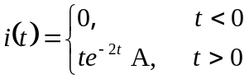

Find the voltage v(t).

